
OSA Data Assessment Report

Personal details | Gender: | M | Age: | 69

Clinical background: | High blood pressure
Patient presentation: | Snoring, daytime fatigue, and unrefreshing sleep. The patient reports waking up feeling tired, has a family history of sleep apnea, and consumes alcohol daily.
Patient goals: | Snoring cessation, Improve daytime sleepiness, Improve daytime energy, Improve sleep quality, Improve morning headaches.

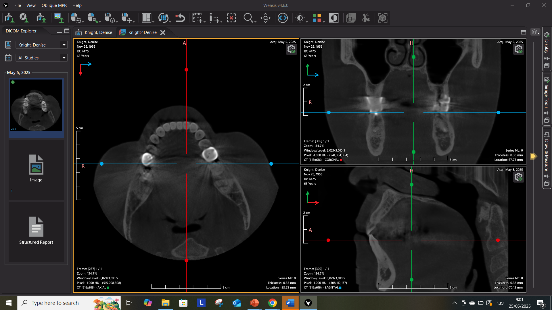


Structural Observations from Imaging Data

Key Observations | Details
Obstruction Sites | Velopharyngeal, oropharyngeal, and tongue base restriction.
Soft Palate & Uvula | Elongated and swollen, partially obstructing the oropharynx.
Tongue Position | Large, posteriorly positioned tongue base encroaching the airway.
Bite & Jaw Structure | increased overjet, reduced overbite and retruded mandibula.
Hyoid Bone | Not viewed
Conclusion: Imaging suggests airway obstruction driven by soft tissue hypertrophy, tongue positioning, and craniofacial anatomy.

Summary and Conclusion:
- The patient presents with typical OSA symptoms, a prior diagnosis and a positive family history.
- Medical history (including hypertension) may worsen with untreated OSA.
- Anatomical findings are consistent with a high risk of persistent airway obstruction.
- The combination of clinical symptoms and anatomical features suggests a high risk for ongoing or worsening OSA.
- Early intervention is advised to improve sleep, reduce daytime fatigue, and prevent health deterioration.
Recommendations for Further Evaluation:
- In light of the patient’s OSA history, persistent symptoms, and comorbid hypertension, further evaluation is recommended to reassess current status and guide treatment.
- Alcohol use may exacerbate sleep-related breathing issues and should be considered in ongoing care planning.
Next Steps – Guidance for the Dental Provider:

- Review Findings with the Patient
  - Schedule a focused consultation
  - Reaffirm diagnosis and explain anatomical findings
  - Emphasize the importance of structured treatment
- Initiate Further Evaluation
  - Refer to sleep specialist
  - Recommend updated sleep test (home or in-lab), without CPAP, if prior test >12 months or CPAP was used
- Complete Documentation for Assessment
  - Request patient to share sleep study results
  - Take clinical photos (per protocol)
  - Perform intraoral digital scan
  - Complete provider questionnaire
  - Upload full case to platform for final report
- Receive Full Assessment Report
  - A personalized treatment recommendation will be generated, including suggested oral appliance options based on the patient’s profile

Talking Points for the Patient Conversation:
- Your symptoms and imaging suggest that OSA remains a health concern.
- Untreated OSA can reduce daytime alertness and increase heart and blood pressure risks.
- Effective treatments are available — including oral appliances, CPAP, lifestyle changes, and surgery.
- The next step is a full evaluation to determine the best treatment approach.
- Our goal is to create a personalized, data-driven plan based on your health profile and goals.

Patient Communication Pitch
Based on your symptoms and imaging findings, it’s clear that obstructive sleep apnea is still playing a role in your health. Untreated OSA can reduce energy, impair mood and memory, and contribute to high blood pressure and cardiovascular risks.
The good news is that effective treatments exist — including oral appliances customized to your unique anatomy. Together, we’ll explore the best options for you, based on your goals like stopping snoring and improving your daytime alertness.
The next step is completing a full evaluation so we can design a data-driven, personalized treatment approach to improve your sleep and long-term well-being.
Depending on your unique anatomy and medical profile, treatment options may include an oral appliance, CPAP therapy, lifestyle adjustments, or, in some cases, surgical intervention.
Our goal is to recommend the most effective and appropriate solution — tailored to your specific needs and supported by real clinical data.

Disclaimer
This AI-generated report is intended as a data assessment tool to support clinical decision-making. It does not constitute a medical diagnosis, treatment recommendation, or radiological interpretation. All imaging findings, including CBCT references, should be reviewed and confirmed by a certified radiologist or qualified healthcare provider. Final treatment decisions must be made by licensed professionals based on a comprehensive clinical evaluation. No liability is assumed for medical decisions made solely on the basis of this report.

